Learning rate comparison experiment, October 9
15 minute training time on 27440 train images and 6853 test images.

0.001 Learning rate Classification Report:
precision recall f1-score support

bright dune 0.94 0.97 0.95 979
crater 0.80 0.79 0.80 979
dark dune 0.96 0.87 0.91 979
impact ejecta 0.97 0.97 0.97 979
slope streak 0.82 0.91 0.86 979
spider 0.95 0.97 0.96 979
swiss cheese 0.89 0.83 0.86 979

accuracy 0.90 6853
macro avg 0.90 0.90 0.90 6853
weighted avg 0.90 0.90 0.90 6853
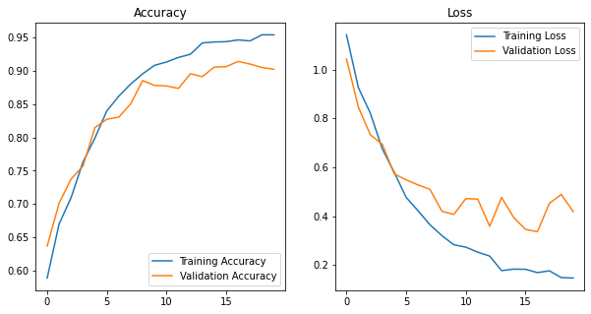
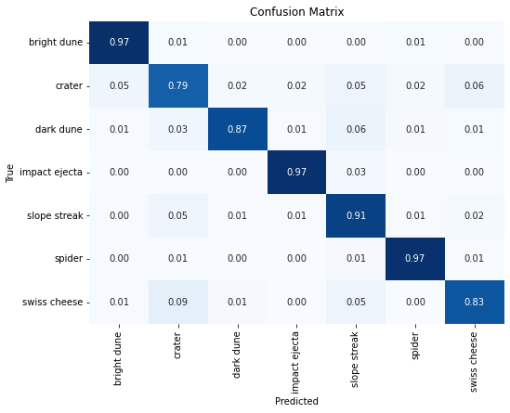
Peak accuracy at 16 epochs

0.0005 learning rate Classification Report:
precision recall f1-score support

bright dune 0.94 0.97 0.95 979
crater 0.90 0.81 0.85 979
dark dune 0.96 0.93 0.95 979
impact ejecta 0.98 0.99 0.98 979
slope streak 0.88 0.89 0.89 979
spider 0.96 0.96 0.96 979
swiss cheese 0.87 0.94 0.91 979

accuracy 0.93 6853
macro avg 0.93 0.93 0.93 6853
weighted avg 0.93 0.93 0.93 6853

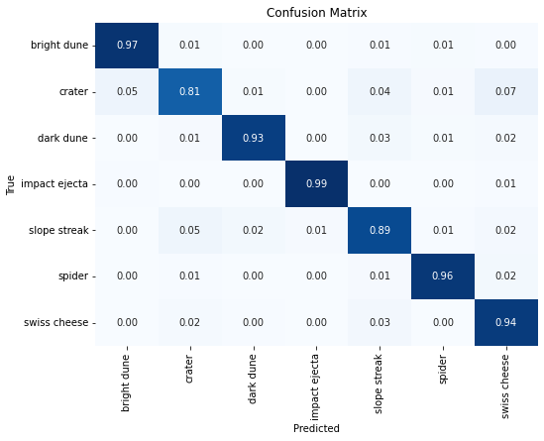
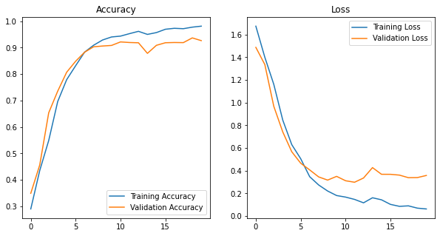
Peak accuracy at 19 epochs
0.0001 learning rate Classification Report:
precision recall f1-score support

bright dune 0.95 0.99 0.97 979
crater 0.90 0.89 0.89 979
dark dune 0.96 0.95 0.95 979
impact ejecta 0.98 1.00 0.99 979
slope streak 0.95 0.91 0.93 979
spider 0.99 0.98 0.99 979
swiss cheese 0.95 0.97 0.96 979

accuracy 0.95 6853
macro avg 0.95 0.95 0.95 6853
weighted avg 0.95 0.95 0.95 6853
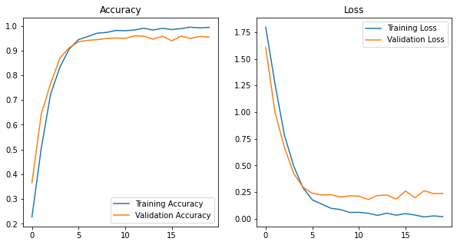
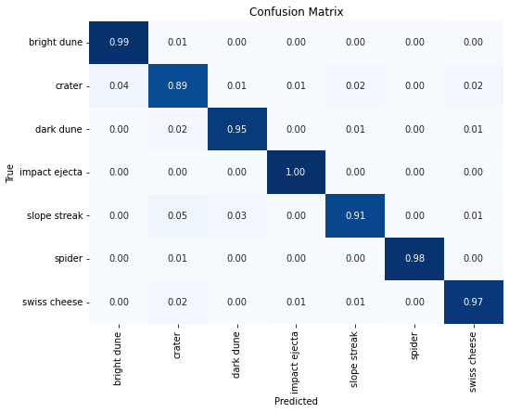
\

Peak accuracy at 16 epochs

0.00001 learning rate Classification Report:
precision recall f1-score support

bright dune 0.89 0.93 0.91 979
crater 0.79 0.64 0.71 979
dark dune 0.83 0.85 0.84 979
impact ejecta 0.82 0.93 0.87 979
slope streak 0.73 0.82 0.77 979
spider 0.92 0.93 0.92 979
swiss cheese 0.90 0.78 0.84 979

accuracy 0.84 6853
macro avg 0.84 0.84 0.84 6853
weighted avg 0.84 0.84 0.84 6853
